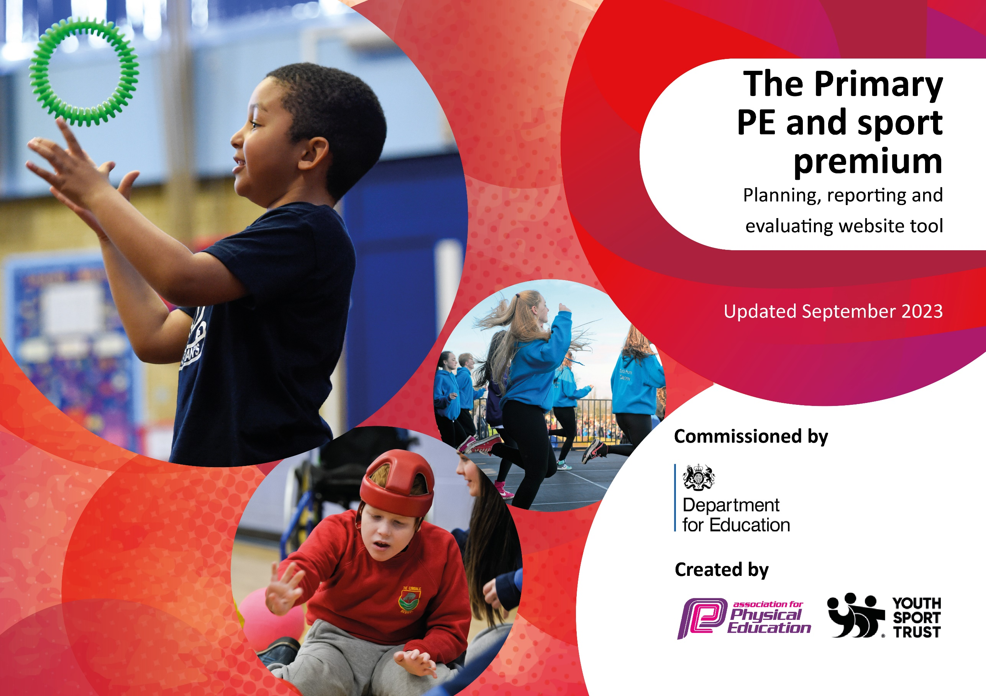

The Primary PE and Sports’ Premium
Review of 2023 24

Activity/Action | Impact | Comments
Gymnastics coaching for all teaching staff  Promotion of physical activity at break times  Additional staff on playgrounds  Lunchtime clubs (Premier Ed)  After school clubs (Premier Ed)  daily mile  Provide and replenish suitable resources.  Weekly Intervention for children within a heavier weight band/with Gross motor or coordination difficulties and or other SEND to participate in regular, weekly exercise.  Increase participation on competition | ongoing CPD  consistency of curriculum delivery  Improved engagement at playtimes  2 x lunchtime opportunities for children across KS2  Every child in school from R - Y6 offered the opportunity for a 6 week after schools multi skills session  Increased agility, balance, confidence and social engagement.  Schools’ Game Mark Gold achieved | The decision has been made to move away from passport to sport and to reintroduce Val Saben for Gymnastics scheme.  For 24 25 new zoning scheme to be introduced.  E C clubs to be aligned with upcoming competitions to improve performance in interschool competitions  Continue to provide this intervention.  Continue to support Intra School competition

Key Priorities and Planning
This planning template will allow schools to accurately plan their spending. 2024 25 Allocation £20,141 (£24,695 projected spend)

Action – what are you planning to do | Who does this action impact? | Key indicator to meet  1: The engagement of all pupils in regular physical activity  2: The profile of PESSPA being raised across the school as a tool for whole school improvement  3: Increased confidence, knowledge and skills of all staff in teaching PE and sport  4: Broader experience of a range of sports and activities offered to all pupils | Impacts and how sustainability to be achieved? | Cost linked to the action
Introduce the Royal Ballet Dance Scheme  Lunchtime organisers and TAs promote purposeful physical play activities at breaks and lunchtimes.  Extracurricular opportunities available to all children  Support participation in Intra school competition  Maintain the School Gold Games Mark  PE lead to be up to date with National and Local position  All staff to feel confident and enthusiastic about delivery of Dance and Gym  Continue to resource the PE and playground equipment requirements.  Increased awareness and participation in a range of sports. | Teachers and children  Los, TAs and children  Children  Children  Children  Teachers and children  Teachers and children  children | 3: Increased confidence, knowledge and skills of all staff in teaching PE and sport  1: The engagement of all pupils in regular physical activity  1: The engagement of all pupils in regular physical activity  2: The profile of PESSPA being raised across the school as a tool for whole school improvement  2: The profile of PESSPA being raised across the school as a tool for whole school improvement  3: Increased confidence, knowledge and skills of all staff in teaching PE and sport  1: The engagement of all pupils in regular physical activity  3: Increased confidence, knowledge and skills of all staff in teaching PE and sport  1: The engagement of all pupils in regular physical activity  4: Broader experience of a range of sports and activities offered to all pupils  1: The engagement of all pupils in regular physical activity  4: Broader experience of a range of sports and activities offered to all pupils | Staff confident to deliver Dance lessons, supported by video materials and cpd.  Ongoing monitoring and coaching support.  Ongoing subscription  Children engaged in purposeful physical activity outside.  Adults engaged in purposeful interactions with children.  On going monitoring and coaching.  Linked to teachers roles and responsibilities  Specific brokered sessions  A wide number of pupils have the opportunity to participate in competitions  Member of the staff team has the responsibility of organizing the schedule and arranging participation.  Release time for the subject lead’s to access CPD  Children and adults enjoy gym and dance lessons  Ongoing coaching and support. | £300 subscription  £1000 4days subject leader time  £17000 30 TA hours pw  £2145 LSC coach  £750 Transport  £1000  £1500 Health and Fitness week activities.

Swimming data Summer 24
Meeting National Curriculum requirements for swimming and water safety.
Priority should always be given to ensuring that pupils can perform safe self-rescue even if they do not fully meet the first two requirements of the National Curriculum programme of study

Question |  | Stats: | Further context  Relative to local challenges
What percentage of your current Year 6 cohort can swim competently, confidently and proficiently over a distance of at least 25 metres? |  | 79%
What percentage of your current Year 6 cohort can use a range of strokes effectively [for example, front crawl, backstroke, and breaststroke]? |  | 82%
What percentage of your current Year 6 cohort are able to perform safe self-rescue in different water-based situations? |  | 84%
If your schools swimming data is below national expectation, you can choose to use the Primary PE and sport premium to provide additional top-up sessions for those pupils that did not meet National Curriculum  requirements after the completion of core lessons. Have you done this? |  | No
Have you provided CPD to improve the knowledge and confidence of staff to be able to teach swimming and water safety? |  | No
Head Teacher: | Kate Bulman
Subject Leader or the individual responsible for the Primary PE and sport premium: | Kate Bulman
Governor:
Date: | July 2024

